Personal Calendar & Self Assessment of Time Management - October

Timetable
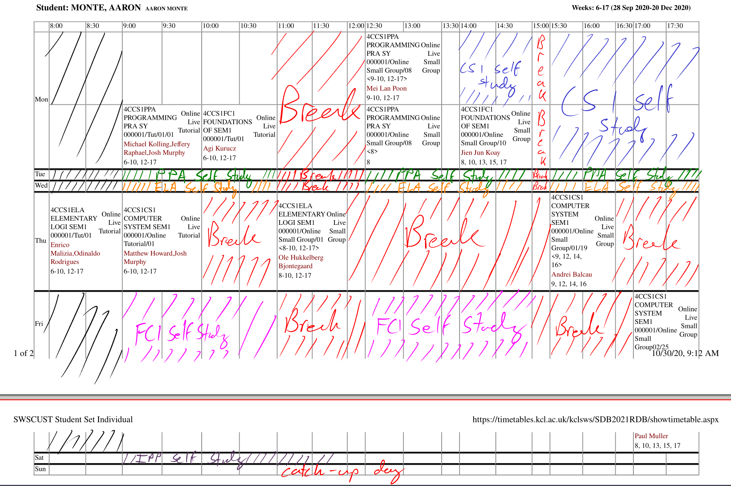
My timetable has been adapted from my school timetable.
Some interesting things to note:
- I like to start off my week (Monday and Tuesday) with the CS1 and PPA because this is the content I find myself most comfortable with. This is to ease myself into the week.
- I dedicate Wednesday and Friday to ELA and FC1 because these are the modules I find more challenging, since mathematics isn’t my strong suit.
- Thursday is mostly a break day because I dislike waking up early in the morning. It kills my mood for the rest of the day. To make up for this, I dedicate time on Saturday for my last module, IPP.
- As this is all self regulated, I may not use all the time I gave, depending on the workload.

Coursework
Aside from the weekly quizzes at the end of each week for each module, I’ve been given two coursework tasks that need to be completed for the month of October.

4CCS1PPA – CS1 Property Viewer
I have previous experience with programming, so I was able to complete the coursework task the day after it was set. I did run into a problem with regards to incompatibility with BlueJ and Linux, but in the end I just finished up the coursework on my old iMac.
I was able to submit the work early with no other issues.

4CCS1RWS – Task B
My job in Task B was to write a song to go with the timelapse video. Since composing vocaloid rock is one of my hobbies, I usually worked on my part of the project outside of the hours on the timetable – often late at night.
We were able to submit the work early with no other issues.

Reading List

Objects First with Java – David J. Barnes & Michael Kolling

Discrete Mathematics and its applications – Kenneth H. Rosen

Essentials of Computer Organization and Architecture – Linda Null & Julia Lobur

Teams Meeting Protocol

General introduction
Just a friendly welcome and short icebreaker by giving an introduction and a personal hobby.

Project ideas
Throw up some ideas on a mind map for what we want to do.
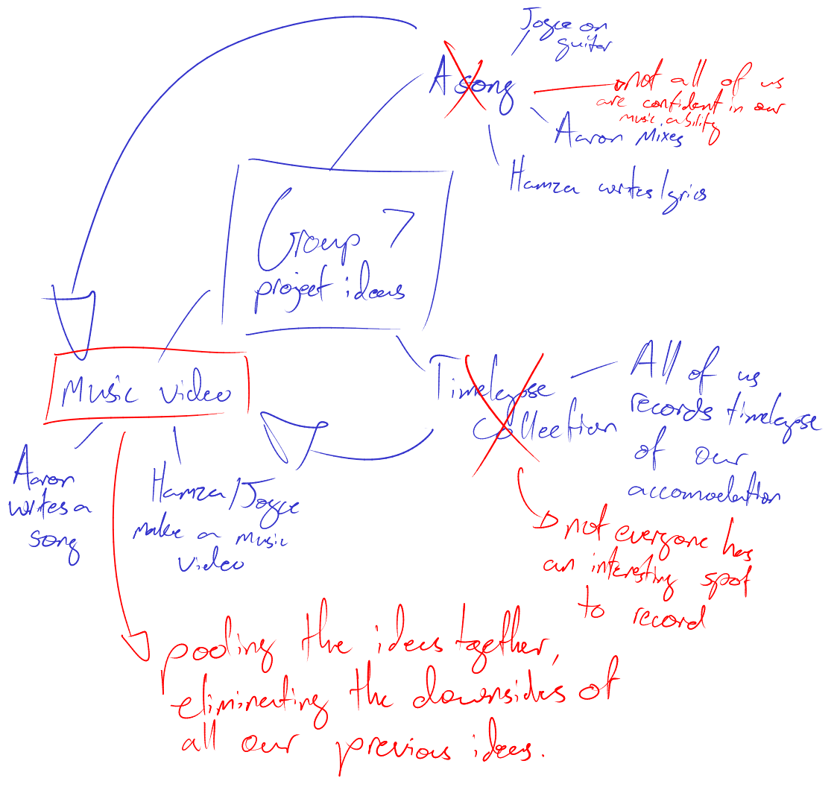

Organising due dates
After selecting a project idea, decide what needs to be done in order to fulfill the requirements for the project, and assign due dates for each of them.
- Video clips in by: 26/10/2020
- Song by: 26/10/2020
- Final draft for video by: 28/10/2020

